**Cloud formation:**

It comes under the category IAAC ---> Infrastructure as a Service

AWS CLI

AWS cloud

Management console GUI

AWS SDK

Cloud formation

Terraform

AWS cloud can be accessed using Management console, AWS CLI, AWS SDK, Cloud formation and Terraform. Both Cloud formation and Terraform come under IaaC category. You have to write code to create infrastructure in AWS. Cloud formation is only specific to AWS. Terraform works with Azure, GCP etc

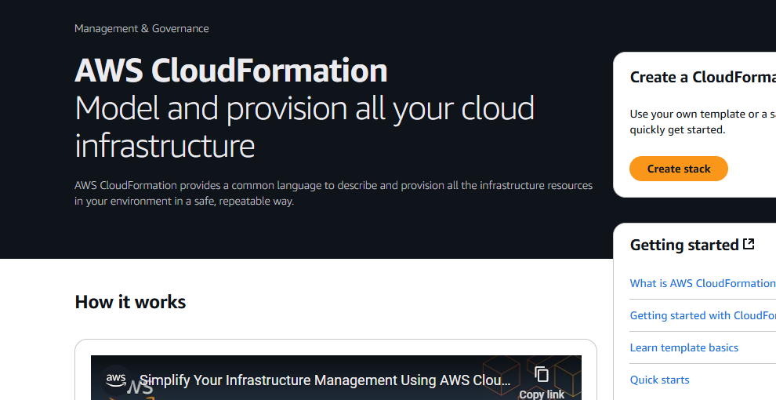

Provisioning means creation of infrastructure

Stopped at: 2:02:00